Time Series Analysis and Descriptive Analysis On Retail Sales Data
Final Project Report

MINI PROJECT (LAB) (IDS753)
B.Tech (DATA SCIENCE IN COLLAB WITH i-Nurture)

PROJECT GUIDE:  Mr. Bhuvnesh Saini sir | SUBMITTED BY:  Krish Vishnoi (TCA2266006)  Arpan Rastogi (TCA2266003)

10/2025



FACULTY OF ENGINEERING & COMPUTING SCIENCES
TEERTHANKER MAHAVEER UNIVERSITY, MORADABAD
Table of Contents

1 Project Title 4
2 Domain 4
3 Problem Statement 4
4 Project Description 4
4.1 Scope of the Work 5
5 Implementation Methodology 5
6 Technologies to be used 5
6.1 Software Platform :- 5
7 SQL for Data Science 5
7.1.1 Importance of SQL in Data Science 5
7.1.2 2.2 SQL Operations for DS 6
7.2 SQL for data science 6
7.3 Normalization 6
7.3.1 Objectives 6
7.3.2 Types of Normal Forms 7
7.4 Views and materialized views 7
7.5 SQL joins 7
8 JOINS in SQL 8
8.1.1 5.1 Types of Joins 8
8.2 Time Series Analysis and Forecasting 8
8.3 What is a Time Series? 8
8.4 Importance of Time Series Analysis 9
8.5 Components of Time Series Data 9
8.6 Time Series Visualization 10
9 Libraries in Python 11
9.1 Working of Python Library 11
9.2 Types of Python Library 11
9.2.1 1. Built-in Python Standard Library 11
9.2.2 2. External Python Libraries 12
10 8. Evaluation Metrics 14
10.1 R-squared vs Adjusted R-squared 14
10.2 What is R-squared? 14
10.3 What is Adjusted R-squared? 15
10.4 Calculating RMSE Using Scikit-learn 16
11 Stationarity of Time Series Data 16
11.1 Kwiatkowski-Phillips-Schmidt-Shin (KPSS) 16
11.2 Importance of Stationarity and the KPSS Test 17
11.3 Augmented Dickey-Fuller (ADF) 17
11.4 Basics of the ADF Test 17
12 Power BI - Key Components 18
12.1 Components of Power Bi 18
12.2 Hardware Platform 19
13 Advantages of this Project 28
14 Future Scope and further enhancement of the Project 29
15 Team Details 30
16 Conclusion 30
17 References 30

Project Title
Time Series Analysis and Descriptive Analysis On Retail Sales Data.

Domain
Data analytics, Time series forecasting, Exploratory Data Analysis, Data Cleaning and Preprocessing, SQL, Normalization, etc.

Problem Statement
To perform a time series and descriptive analysis and providing suggestion to firm providing the data of their retail sales, so that the stakeholders know about the current situation and are aware of the future, based on the current situation.

Project Description
The project integrates multiple business domains to help the firm assess and improve its performance over time. Historical and current data are carefully processed to extract meaningful insights and ensure efficient database management. A normalized database structure has been designed to eliminate redundancy and minimize the risk of faulty or inconsistent data in future operations.
Data science integrates statistical modelling, machine learning, business intelligence, and database systems to extract insights from data. A complete project flow involves problem definition, data handling, modelling, validation, and deployment.
This report covers essential topics used in data science, including SQL concepts, normalization, analytical views, statistical tests, time series analysis, evaluation metrics, and analytics through tools like Power BI.The sections are aligned with industry-standard workflows and academic expectations.
All previously erroneous or unorganized records have been cleaned and migrated into a robust, well-structured system. The refined data is analysed using SQL to uncover hidden insights and trends. This analysed data is then utilized in Power BI for interactive dashboards and in Python for Time Series Analysis and forecasting.
While Power BI dashboards visually communicate trends and KPIs to stakeholders and non-technical users, Python-based analysis provides predictive insights for strategic decision-making. The project focuses on various business aspects such as sales performance, customer behaviour, product trends, postal code coverage, order management, and shipping efficiency. These insights assist management and the finance department in making data-driven decisions and formulating new strategies for business growth.

Scope of the Work

•Create a normalized database for effective data storage and effective management and retrieval from it.
•Provide current business insights using SQL.
•Provide as accurate as possible future predictions using time series analysis and python.
•Create a dashboard in power-bi for easy and effective communication over the analysis.

Implementation Methodology

- A random retails sales data is taken from Kaggle.
- The dataset is then put into a PostgreSQL database (pgAdmin4) for creating a normalized database structure and model.
- The normalized database is then analyzed within the pgAdmin4 for hidden insights.
- The database is then used in python for time series analysis and future predictions.
- Finally, the database is imported in power-bi for dashboarding of it.

Technologies to be used

Software Platform :-

SQL for Data Science

Structured Query Language (SQL) is the backbone of data extraction and manipulation in data science workflows. SQL allows data analysts to prepare datasets, perform joins, create views, and optimize queries. SQL is a domain-specific language designed for managing structured data stored in tables with rows and columns in relational database systems. It is standardized by ANSI and ISO, so the same core syntax works across many database products such as MySQL, SQL Server, Oracle, and PostgreSQL.

Importance of SQL in Data Science
SQL is widely used because it can handle large datasets efficiently and express complex queries in a concise, declarative way. Its standardization and support across many systems make it a core skill for working with data in software development, analytics, and database administration.
- Fetching datasets from relational databases
- Cleaning and filtering data
- Combining tables for analysis
- Feature engineering using SQL
- Aggregations for descriptive analytics
- Implementing prescriptive rules using stored procedures and scripts

2.2 SQL Operations for DS
- SELECT, WHERE, GROUP BY, HAVING, ORDER BY
- Subqueries and nested queries
- Window functions: ROW_NUMBER, RANK, LEAD, LAG
- Aggregates: SUM(), AVG(), COUNT(), MIN(), MAX()
- Conditional functions: CASE WHEN
These skills help generate structured datasets before sending them to Python or R for modeling.

SQL for data science
SQL is used in data science to extract, clean, aggregate, and join data from relational databases before modelling or visualization. Typical workflows include selecting relevant columns, filtering rows, grouping by dimensions, and joining multiple tables to create analysis-ready datasets.
Common SQL features for data science include subqueries, window functions (for running totals, rankings, lags), and CTEs, which help build complex analytical queries in readable steps.

Normalization
Normalization is the process of structuring relational tables to reduce redundancy and anomalies while maintaining data integrity. It uses normal forms (1NF, 2NF, 3NF, BCNF) that impose rules on keys and dependencies so that each fact is stored in exactly one place when possible.

Objectives
- Minimize duplicated data
- Ensure data dependency integrity
- Improve query efficiency
- Reduce update anomalies

Types of Normal Forms

1NF (First Normal Form)
- No repeating groups
- Atomic values only

2NF (Second Normal Form)
- 1NF + No partial dependency
- Full functional dependency on primary key

3NF (Third Normal Form)
- 2NF + No transitive dependency
- Every non-key attribute depends only on primary key

BCNF (Boyce-Codd Normal Form)
- Every determinant must be a candidate key
Normalization ensures datasets are consistent before analysis.
Benefits include smaller storage footprint, easier updates, and more consistent data, at the cost of potentially more joins when querying highly normalized schemas.

Views and materialized views
A (normal) view is a virtual table defined by a query; it does not store data itself but runs the underlying query each time it is referenced. Views are useful for simplifying complex queries, enforcing row/column-level security, and providing stable interfaces over changing schemas.
A materialized view stores the result of a query physically on disk and can be refreshed periodically or incrementally, which greatly speeds up repeated analytical queries on large datasets. Because the data is stored, the system must maintain consistency via refresh strategies such as on-commit, on-demand, or scheduled refresh.

SQL joins
Joins combine rows from two or more tables based on matching key columns, allowing reconstruction of denormalized analysis tables. The main types are inner join (keep matches only), left/right join (keep all rows from one side plus matches), and full outer join (all rows from both sides with matches where possible).
Data science queries often rely on joins between fact tables (transactions, events) and dimension tables (customers, products, dates) to create feature-rich datasets for modelling and reporting.

JOINS in SQL
Joins combine data from multiple tables.

5.1 Types of Joins
- INNER JOIN: common records from both tables
- LEFT JOIN: all records from left, matching from right
- RIGHT JOIN: all records from right, matching from left
- FULL OUTER JOIN: all records from both sides
- CROSS JOIN: Cartesian product
- SELF JOIN: table joined with itself

Time Series Analysis and Forecasting

Time series analysis and forecasting are crucial for predicting future trends, behaviors, and behaviours based on historical data. It helps businesses make informed decisions, optimize resources, and mitigate risks by anticipating market demand, sales fluctuations, stock prices, and more. Additionally, it aids in planning, budgeting, and strategizing across various domains such as finance, economics, healthcare, climate science, and resource management, driving efficiency and competitiveness.

What is a Time Series?

A time series is a sequence of data points collected, recorded, or measured at successive, evenly-spaced time intervals.
Each data point represents observations or measurements taken over time, such as stock prices, temperature readings, or sales figures. Time series data is commonly represented graphically with time on the horizontal axis and the variable of interest on the vertical axis, allowing analysts to identify trends, patterns, and changes over time.
Time series data is often represented graphically as a line plot, with time depicted on the horizontal x-axis and the variable's values displayed on the vertical y-axis. This graphical representation facilitates the visualization of trends, patterns, and fluctuations in the variable over time, aiding in the analysis and interpretation of the data.

Importance of Time Series Analysis

Predict Future Trends: Time series analysis enables the prediction of future trends, allowing businesses to anticipate market demand, stock prices, and other key variables, facilitating proactive decision-making.
Detect Patterns and Anomalies: By examining sequential data points, time series analysis helps detect recurring patterns and anomalies, providing insights into underlying behaviors and potential outliers.
Risk Mitigation: By spotting potential risks, businesses can develop strategies to mitigate them, enhancing overall risk management.
Strategic Planning: Time series insights inform long-term strategic planning, guiding decision-making across finance, healthcare, and other sectors.
Competitive Edge: Time series analysis enables businesses to optimize resource allocation effectively, whether it's inventory, workforce, or financial assets. By staying ahead of market trends, responding to changes, and making data-driven decisions, businesses gain a competitive edge.

Components of Time Series Data

There are four main components of a time series:
Trend: Trend represents the long-term movement or directionality of the data over time. It captures the overall tendency of the series to increase, decrease, or remain stable. Trends can be linear, indicating a consistent increase or decrease, or nonlinear, showing more complex patterns.
Seasonality: Seasonality refers to periodic fluctuations or patterns that occur at regular intervals within the time series. These cycles often repeat annually, quarterly, monthly, or weekly and are typically influenced by factors such as seasons, holidays, or business cycles.
Cyclic variations: Cyclical variations are longer-term fluctuations in the time series that do not have a fixed period like seasonality. These fluctuations represent economic or business cycles, which can extend over multiple years and are often associated with expansions and contractions in economic activity.
Irregularity (or Noise): Irregularity, also known as noise or randomness, refers to the unpredictable or random fluctuations in the data that cannot be attributed to the trend, seasonality, or cyclical variations. These fluctuations may result from random events, measurement errors, or other unforeseen factors. Irregularity makes it challenging to identify and model the underlying patterns in the time series data.

Time Series Visualization

Time series visualization is the graphical representation of data collected over successive time intervals. It encompasses various techniques such as line plots, seasonal subseries plots, autocorrelation plots, histograms, and interactive visualizations. These methods help analysts identify trends, patterns, and anomalies in time-dependent data for better understanding and decision-making.
Different Time series visualization graphs
Line Plots: Line plots display data points over time, allowing easy observation of trends, cycles, and fluctuations.
Seasonal Plots: These plots break down time series data into seasonal components, helping to visualize patterns within specific time periods.
Histograms and Density Plots: Shows the distribution of data values over time, providing insights into data characteristics such as skewness and kurtosis.
Autocorrelation and Partial Autocorrelation Plots: These plots visualize correlation between a time series and its lagged values, helping to identify seasonality and lagged relationships.
Spectral Analysis: Spectral analysis techniques, such as periodograms and spectrograms, visualize frequency components within time series data, useful for identifying periodicity and cyclical patterns.
Decomposition Plots: Decomposition plots break down a time series into its trend, seasonal, and residual components, aiding in understanding the underlying patterns.

Libraries in Python

In Python, a library is a group of modules that contain functions, classes and methods to perform common tasks like data manipulation, math operations, web scraping and more. Python libraries make coding faster, cleaner and more efficient by providing ready-to-use solutions for different domains such as data science, web development, machine learning and automation.

Working of Python Library

When you import a library in Python, it gives access to pre-written code stored in separate modules. In simple terms instead of writing the logic for a task, you import the library that already has it.
For example, on Windows, libraries are stored as .dll (Dynamic Link Libraries) and on Linux/macOS as .so files. When you run your code, Python automatically loads these modules and makes their functions available to use.

Types of Python Library

Python libraries are divided into two main types:

1. Built-in Python Standard Library

It is a collection of modules that come bundled with every Python installation, we don’t need to install anything separately. Most of these modules are written in C for better performance.
Examples of built-in modules:
math: Mathematical operations
os: Interact with the operating system
datetime: Date and time operations
random: Generate random numbers
json: Handles JSON data encoding and decoding.

2. External Python Libraries

External (third-party) libraries are not included with Python by default. You can install them easily using the pip package manager. Popular External Python Libraries:

NumPy: It, short for Numerical Python, is the core library for numerical and scientific computing in Python. It provides powerful tools for creating and manipulating arrays, matrices and multidimensional data. NumPy is a core Python library for numerical computing, built for handling large arrays and matrices efficiently. It is significantly faster than Python's built-in lists because it uses optimized C-based operations and supports vectorized computations.
ndarray object: Stores homogeneous data in n-dimensional arrays for fast processing.
Vectorized operations: Perform element-wise calculations without explicit loops.
Broadcasting: Apply operations across arrays of different shapes.
Linear algebra functions: Matrix multiplication, inversion, eigenvalues, etc.
Statistical tools: Mean, median, standard deviation, and more.
Fourier transforms: Fast computation for signal and image processing.
Integration with other libraries: Works seamlessly with Pandas, SciPy, and scikit-learn.

Pandas: It is a data analysis and manipulation library built on top of NumPy. It introduces data structures like DataFrame and Series that make it easy to handle structured data efficiently. Pandas (stands for Python Data Analysis) is an open-source software library designed for data manipulation and analysis.
Revolves around two primary Data structures: Series (1D) and DataFrame (2D)
Built on top of NumPy, efficiently manages large datasets, offering tools for data cleaning, transformation, and analysis.
Tools for working with time series data, including date range generation and frequency conversion. For example, we can convert date or time columns into pandas’ datetime type using pd.to_datetime(), or specify parse_dates=True during CSV loading.
Seamlessly integrates with other Python libraries like NumPy, Matplotlib, and scikit-learn.
Provides methods like .dropna() and .fillna() to handle missing values seamlessly

Matplotlib: It is a data visualization library that helps you create a wide variety of static, animated and interactive plots. It supports charts such as bar graphs, line charts, histograms and scatter plots. Matplotlib is an open-source visualization library for the Python programming language, widely used for creating static, animated and interactive plots. It provides an object-oriented API for embedding plots into applications using general-purpose GUI toolkits like Tkinter, Qt, GTK and wxPython. It offers a variety of plotting functionalities, including line plots, bar charts, histograms, scatter plots and 3D visualizations. Created by John D. Hunter in 2003, Matplotlib has become a fundamental tool for data visualization in Python, extensively used by data scientists, researchers and engineers worldwide.

SciPy: It, short for Scientific Python, extends the functionality of NumPy by providing tools for advanced mathematical, scientific and engineering computations. It includes modules for optimization, integration, signal processing and linear algebra.

TensorFlow: It is an open-source machine learning and deep learning framework developed by Google. It allows developers to build and train neural networks for tasks such as image recognition, natural language processing and predictive modeling.

Scikit-learn: It is a popular machine learning library built on top of NumPy and SciPy. It offers simple and efficient tools for classification, regression, clustering and dimensionality reduction.

8. Evaluation Metrics

Evaluating a model’s accuracy and predictive performance is crucial.When it comes to evaluating the performance of a regression model, two metrics often take center stage: R-squared and adjusted R-squared. These statistical measures are crucial for assessing how well a model explains the variation in the dependent variable, but they serve different purposes and offer distinct insights.

R-squared vs Adjusted R-squared

The prime difference between R-squared and Adjusted R-squared lies in how they account for the number of predictors in a regression model:
R-squared measures the proportion of variance in the dependent variable explained by the independent variables. It always increases when more predictors are added, regardless of their relevance to the model.
Adjusted R-squared, on the other hand, adjusts the R-squared value based on the number of predictors in the model. It accounts for the degrees of freedom, penalizing the addition of irrelevant predictors. As a result, Adjusted R-squared can decrease if a new predictor does not improve the model sufficiently.
In this article, we will understand differences of R-squared and adjusted R-squared, exploring their definitions, calculations, and the mathematics between them.

What is R-squared?

R-squared or the coefficient of determination, is the statistical measure of the variance of the regression (best fit) line from the actual data points. In a generalized linear regression model the model accuracy ranging from 75 - 95% is considered as a good prediction model, whereas 100% accuracy means overfitting.
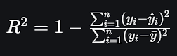
where,
Numerator is sum of squares of the residuals (the difference between the observed and predicted values).
and Denominator is is the total sum of squares (the variance of the observed data).
R-squared values range from 0 to 1:
An R-squared of 0 indicates that the model explains none of the variability of the dependent variable.
An R-squared of 1 indicates that the model explains all the variability of the dependent variable.

What is Adjusted R-squared?

Adjusted R-squared is a performance metrics which can be termed as a more refined version of R-squared which priorities the input features that correlates with the target variable. It takes into account the number of predictors in the model and whether they are significant. While R-squared always increases when more predictors are added, Adjusted R-squared increases only if the new predictors genuinely improve the model. It prevents overfitting by balancing the model’s performance with its complexity. Formula for Adjusted R-squared is:

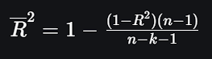
n = number of data points (observations)
k = number of predictors (features)

A higher Adjusted R-squared indicates that the model fits the data well without including unnecessary predictors, suggesting that the chosen features are meaningful and contribute to explaining the variability in the dependent variable. On the other hand, a lower or negative Adjusted R-squared suggests that adding more predictors does not improve the model’s performance and may even harm it. This occurs when extra predictors add noise rather than value.

Calculating RMSE Using Scikit-learn

Root Mean Square Error is a metrics used for evaluating the accuracy of regression models. It measures the average size of the errors between predicted and actual values by taking the square root of the mean of squared differences. RMSE helps determine how close the model’s predictions are to real outcomes with lower values indicating better prediction accuracy.
The formula for RMSE is:
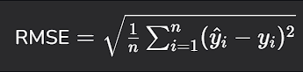
Here,
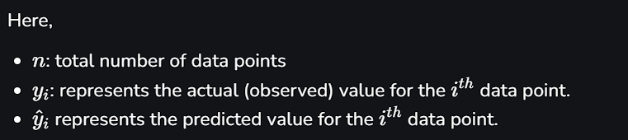

Stationarity of Time Series Data

Stationarity is an important concept when working with time series data. A stationary time series is one whose statistical properties, such as mean, variance, and autocorrelation, remain constant over time. Stationary data is easier to model and analyze.

Kwiatkowski-Phillips-Schmidt-Shin (KPSS)

The KPSS test, is used for assessing the stationarity of a time series. In contrast to the ADF test, which tests the null hypothesis that a series has a unit root (i.e., is non-stationary), the KPSS test assumes the series is stationary under the null hypothesis and looks for evidence to reject that assumption.

Importance of Stationarity and the KPSS Test

Stationarity is important in time series forecasting because models like ARIMA, Exponential Smoothing and Prophet assume that the input data is stationary. If the data is non-stationary i.e., its mean and variance change over time these models can produce inaccurate forecasts and misleading conclusions. Due to its importance, checking for stationarity is often the very first step before applying any forecasting model.
The KPSS (Kwiatkowski-Phillips-Schmidt-Shin) test checks whether a time series is stationary around a mean or deterministic trend. It tests the null hypothesis that the series is stationary.

Augmented Dickey-Fuller (ADF)

Augmented Dickey-Fuller (ADF) test is a statistical test in time series analysis used to determine whether a given time series is stationary. A stationary time series has constant mean and variance over time, which is a core assumption in many time series models, including ARIMA.
In time series modeling, stationarity ensures that the model's performance is consistent over time. Non-stationary data can produce misleading forecasts and incorrect inferences. That’s why one of the first steps in time series analysis is testing for stationarity and that's where the ADF test comes in.

Basics of the ADF Test

The Augmented Dickey-Fuller test is an extended version of the Dickey-Fuller test. It tests the null hypothesis that a unit root is present in a time series sample. The presence of a unit root means the series is non-stationary.

Power BI - Key Components

Power BI is a data visualization and business intelligence tool created by Microsoft. It helps us to turn raw data into easy to understand reports and interactive dashboards which non-technical users can also create easily. In this article, we will understand its key components.

Components of Power Bi

1. Power Query
Power Query is the first step in working with data in Power BI. It allows you to connect to different data sources like Excel files, databases, web pages or even cloud-based services. Once the data is imported Power Query helps you to clean, transform and shape it into a useful format.
We can remove unnecessary rows, change column names, combine data from multiple tables and much more all without programming using Power BI. This process is called “data wrangling" and Power Query makes it easy and visual.

2. Power View
Power View helps us to create visuals and reports by simply dragging and dropping data fields. It support wide range of chart types like bar charts, pie charts, line charts, maps and more.
It’s interactive which means you can click on parts of the chart to filter other parts of the report. It is mainly used to explore your data visually and discover trends. It is helpful for users who prefer to see patterns through visuals rather than numbers.

3. Power BI Desktop
Power BI Desktop is the main platform where most of the work happens. It combines all the features like Power Query (for cleaning data), Power Pivot (for modeling data) and Power View (for visualizing data) into one tool. This is where you build complete reports and dashboards.
This interface is user-friendly and it allows you to design everything offline before publishing it online. It is like workshop were we prepare everything here before sharing it with our team or organization.

4. Power BI Service
After we create our reports in Power BI Desktop you can publish them to the Power BI Service which is also known as the Power BI Website. Here we can share your reports with others, collaborate in teams and access your data from any device using a browser.
It’s a cloud-based platform that also lets us schedule data refreshes and receive automatic updates. We can also create dashboards here by pinning visuals from different reports into one view for easy monitoring.

5. Power Pivot
Power Pivot is the engine behind the scenes that helps you work with large datasets quickly. It lets you create data models which means you can link different tables together and use formulas (called DAX formulas) to perform calculations.
Even if you have millions of rows it compresses the data and processes it efficiently. This is great for building powerful reports without slowing down your system. It’s especially useful for users who want to do in-depth analysis.

6. Power Map
Power Map is used when your data includes geographical locations like countries, cities or coordinates. It creates 3D maps that let you view your data based on location. You can see patterns like sales by region, customer distribution or delivery routes.
The maps are animated and you can even show changes over time. For example, how sales grew across different areas month by month.
Power BI brings together powerful tools to connect, analyze and visualize data in one place. Its flexible components make it easy for anyone to turn raw data into meaningful insights.

Hardware Platform
Laptop with Ryzen 5625u, 8gm RAM, 512gb SSD.

ERP Diagram

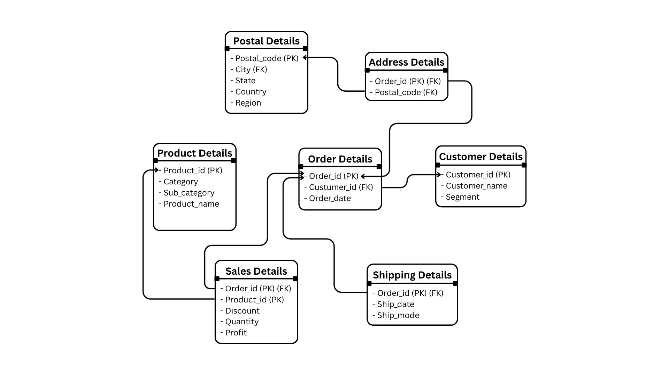

SALES PERFORMANCE DASHBOARD
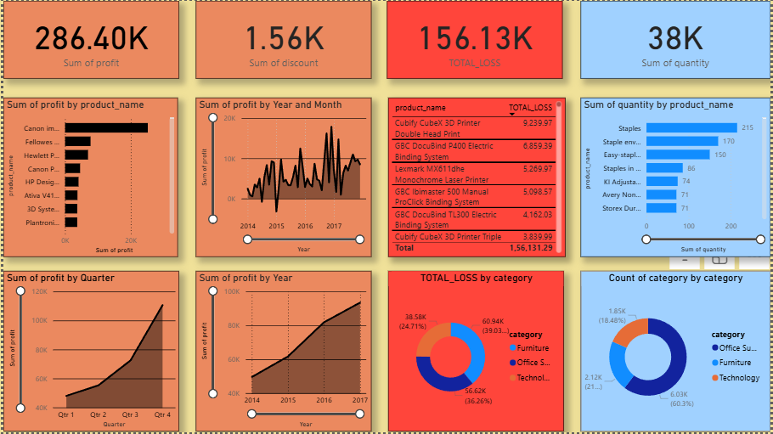

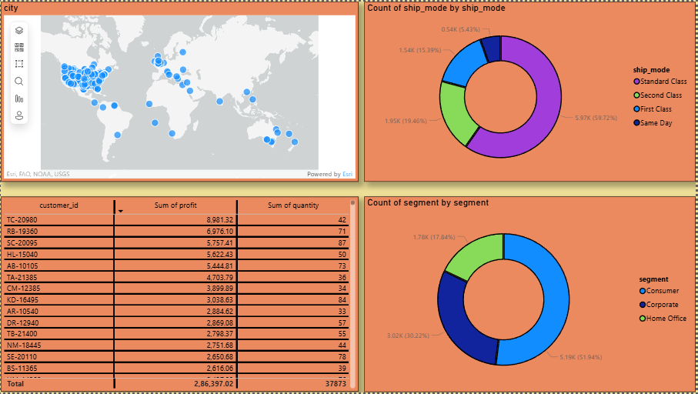

SQL CODES

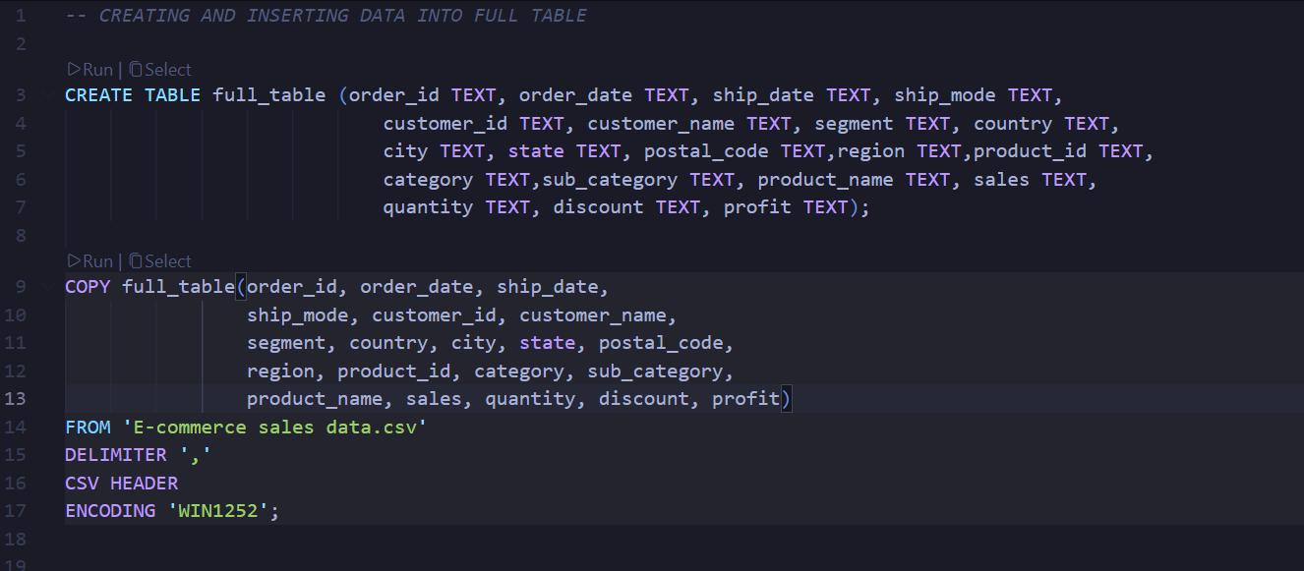

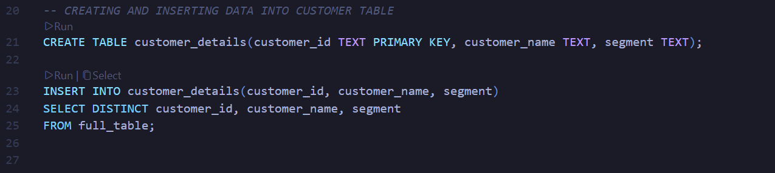

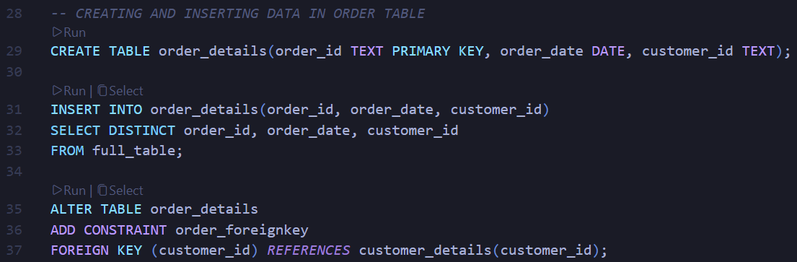

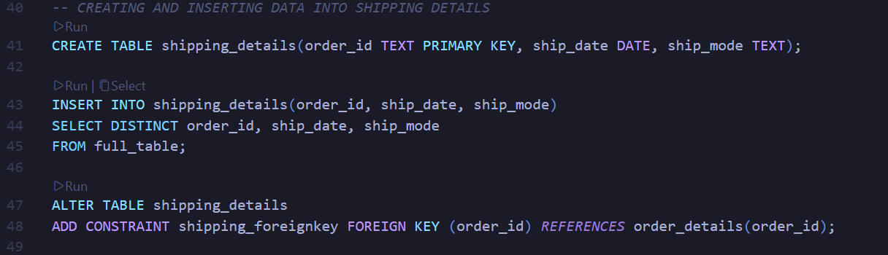

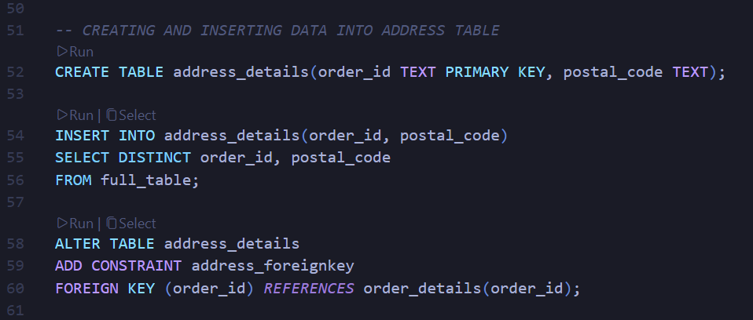
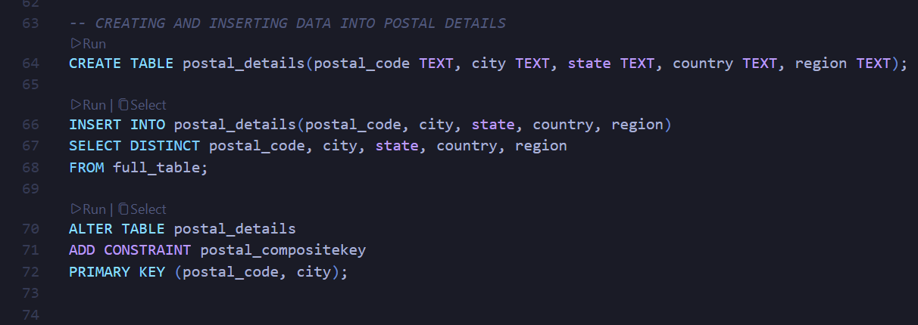
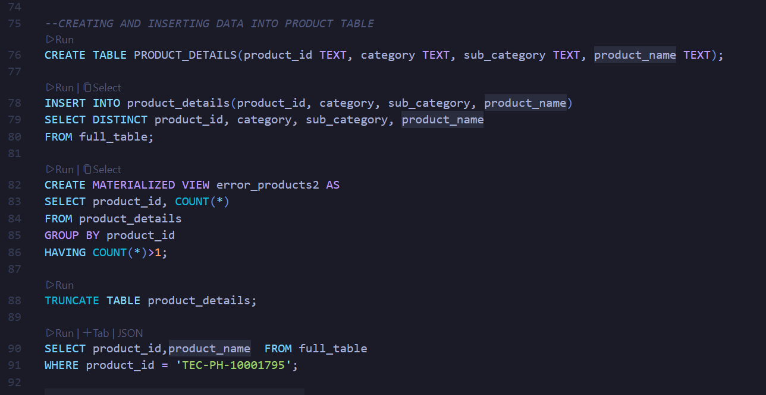

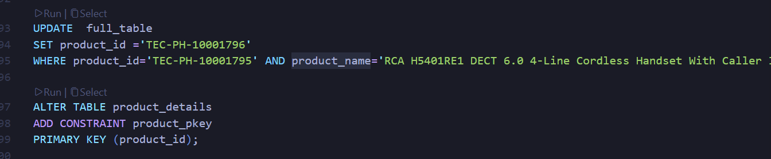

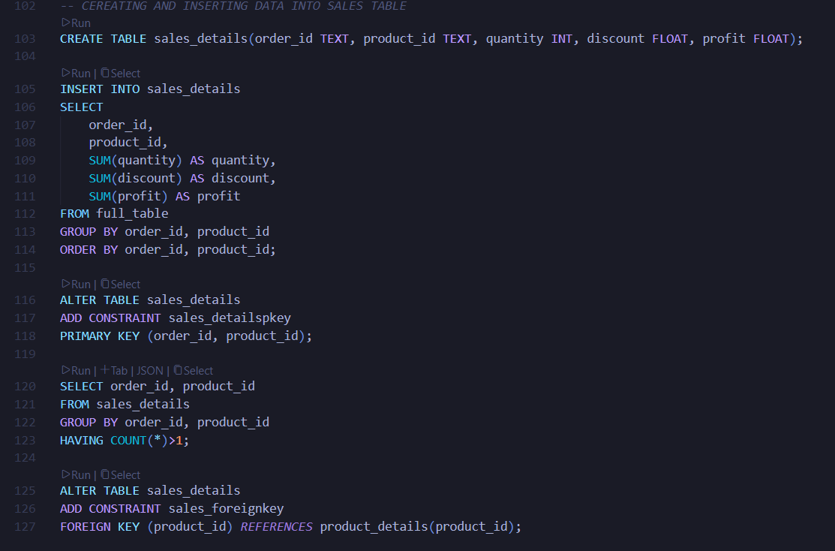

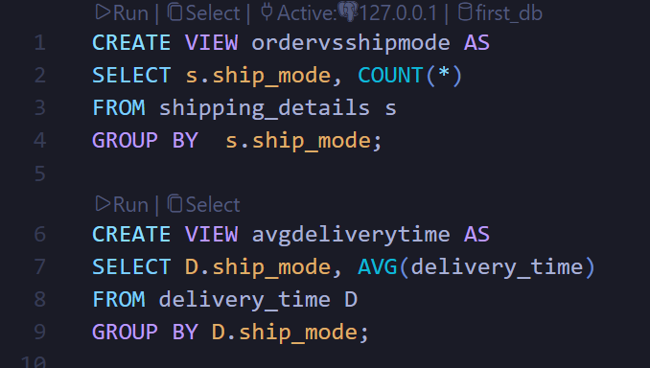

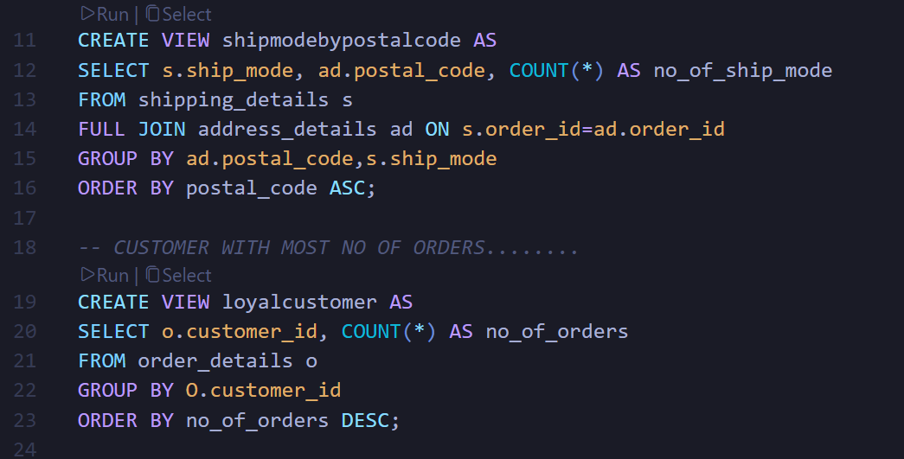
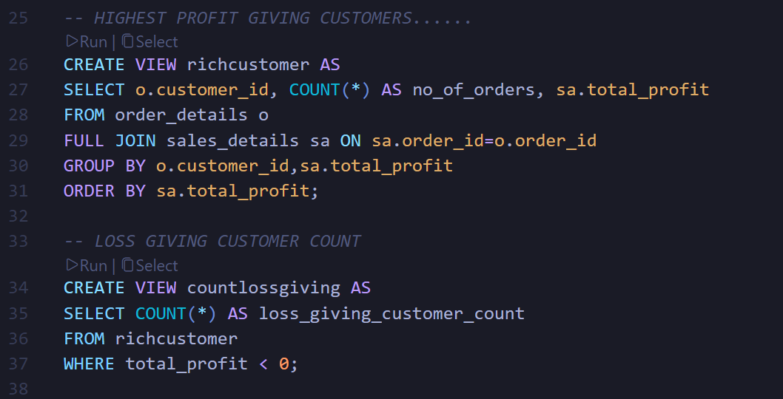

Advantages of this Project
- Improved Data Quality:
The normalization process ensures that data redundancy and inconsistencies are minimized, leading to more accurate reporting and analysis.

- Centralized Data Management:
All business domains (sales, customers, products, shipping, etc.) are integrated into a unified database, simplifying access and maintenance.

- Enhanced Decision-Making:
Real-time dashboards and analytical reports enable management to make informed and timely decisions based on concrete data insights.

- Predictive Capabilities:
Time Series Analysis in Python helps forecast future sales, demand, and customer trends, supporting proactive planning.

- Ease of Understanding:
Visual dashboards in Power BI make complex data insights easily interpretable by non-technical stakeholders.

- Error-Free Future Storage:
By eliminating faulty and duplicate entries, future data entries remain clean and reliable for analytics.

- Operational Efficiency:
The integration of automation in data analysis and visualization reduces manual workload and boosts overall productivity.

Future Scope and further enhancement of the Project
- Integration with Real-Time Data Streams:
The system can be upgraded to capture live sales and customer data for dynamic, up-to-the-minute dashboards.

- Machine Learning Implementation:
Predictive models can be expanded to include customer segmentation, churn prediction, and product recommendation systems.

- Cloud-Based Deployment:
Hosting the database and dashboards on cloud platforms (e.g., AWS, Azure) will improve scalability and accessibility across departments.

- Advanced Forecasting Models:
Use of ARIMA, Prophet, or LSTM models in Python can improve the accuracy of future trend predictions.

- Automation of Reporting:
Scheduled SQL queries and automated Power BI refreshes can ensure stakeholders always have updated insights.

- Integration with ERP/CRM Systems:
Linking the analytical system with operational tools can enable seamless business intelligence and customer relationship management.

Team Details

Project Name & ID | Course Name | Student ID | Student Name | Role | Signature
Time Series Analysis And Descriptive Analysis On Retail Sales Data. | B.Tech (DATA SCIENCE) | TCA2266066 | KRISH VISHNOI | Complete development
Time Series Analysis And Descriptive Analysis On Retail Sales Data. | B.Tech (DATA SCIENCE) | TCA2266003 | ARPAN RASTOGI | Model & Output Evaluation

Conclusion
This project successfully combines database normalization, SQL analytics, Power BI visualization, and Python forecasting to deliver a complete data-driven decision support system. It not only improves the firm’s data integrity and operational efficiency but also empowers stakeholders with actionable insights. The comprehensive analytical framework ensures better business planning, performance tracking, and strategy formulation, positioning the organization for sustained growth and competitiveness in the market.

References
•SQL & PGADMIN4 : https://www.postgresql.org/download
•JUPYTER : https://jupyter.org/install
•PYTON : https://www.python.org/downloads
• POWER-BI : https://www.microsoft.com/en-us/download/details.aspx?id=58494
•DATASET : https://www.kaggle.com/datasets/claudiojnior/u-s-retail-dataset
•GeeksforGeeks : GeeksforGeeks | Your All-in-One Learning Portal

